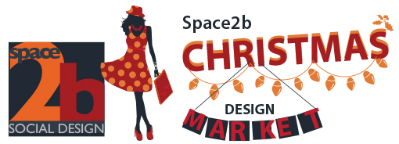

The Astor Theatre - The SPACE2b for your christmas stall
high profile - huge publicity - great designers

Make an impact and make a difference
secure your stall and support a design future for a new Australian!
____________________________________________

Presented by RAW & SPACE2b with the Astor Theatre

Space2b, Raw and The Astor have partnered to present this annual designer Christmas market

UNIQUE EVENT

Be a part of the Space2b Social Design Market where all profits will go to supporting newly arrived migrant and refugees

A mix of stalls from carefully selected top Australian designers
The number of stalls will be limited so your products will stand out!
+
Astor vintage poster sale

GREAT PUBLICITY

The Astor have a huge publicity campaign to bring in the crowds

The Astor Theatre publicity: 10,000 email list, 15,000 mail out and busy blog page
Space2b & RAW members and supporting organisation

We have great local connections with the City of Port Phillip and Stonnington and the local Leader papers and three of the main local schools
all of which support our cause and will help to promote the event

We will be expecting over 2000 people

FANTASTIC DESIGNERS

We are looking for designers producing well crafted and inspiring products
jewellery, fashion, furniture, homewares, textiles, stationery, illustration, handmade beauty products and more

You must be an Australian Designer

SUPPORTIVE PRICES

Stalls $120
____________________________________________

APPLICATION NOW OPEN
please fill out attached pdf and send back to admin@space2b.com.au

Application close July 30th

view our facebook event


____________________________________________

