ArtSpace Gallery Terms and Conditions

About Space2b
Space 2b is a social enterprise supporting newly arrived migrants, refugees and people seeking asylum to become financially independent. Space2b workspace includes a shop, ArtSpace Gallery, design studio, workshop, café (currently closed) and small business hub in the City of Port Phillip.

Exhibition Space
The ArtSpace Gallery at Space2b is situated between our retail area and café. It is equipped with a gallery hanging system with 4 large and 2 smaller walls with lighting and is managed by Violet Browne, Gallery & Programs Manager together with Space2b staff and trained volunteers.

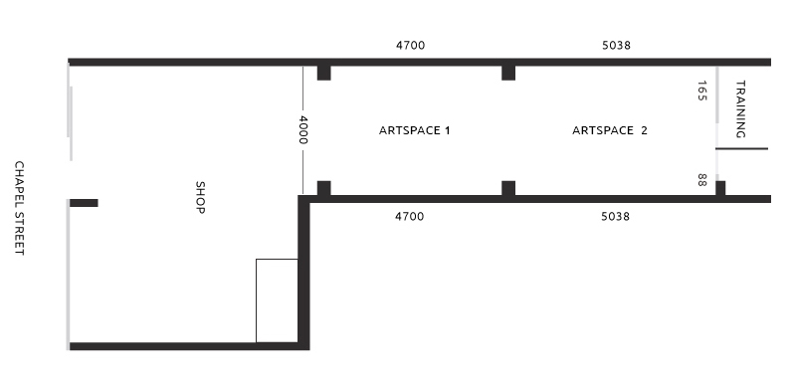
The ArtSpace Gallery is a unique exhibition space as it part of a Retail Shop with a multitude of quality fashion, children’s and adults clothing items as well as a huge range of gifts. It therefore enables your artwork to be exposed to art enthusiasts, workshop and event attendees, and visitors to the shop and café.

As a registered not-for-profit, in exhibiting with us you are also supporting the running of our diverse Programs and events. We attract both professional and emerging artists and are able to give artists exhibiting for the first time, additional mentoring and support.

- Exhibition openings are usually held on Friday nights between 6pm – 8pm.
- Installation of the exhibition is on Mondays when the shop is closed. All art works must be dropped off and picked up on the day specified. We do not have space to store paintings left behind.
- ArtSpace Gallery is open Tuesday to Friday: 10am - 5pm Saturday: 10am –2 pm **
- Due to the nature of the space, sometimes bookings are made for other events, workshops or training during the opening hours.
- If at all possible, it is advisable visit the ArtSpace Gallery to inspect the space, prior to applying.

Costs
- Minimum of 4 weeks at $600 for individuals or groups of up to 2 exhibiting artists.
- Group show of 3 to 4 artists $800. Group show with 5 or more artists: price negotiable (please contact ArtSpace team to discuss).
- ArtSpace reserves two months each year for a free exhibition for newly arrived migrants/refugees. (Commission is higher to cover costs, as no Gallery fee is charged for these exhibitions. See ‘Commission’ below
- Duration can be longer or shorter by negotiation.
- Fee is payable at time of confirmation and completion of Terms and Conditions/Application fee.
- Cancellation fee is 50% of booking fee if cancelled within 4-8 weeks of exhibition. Full fee payable if cancelled less than 4 weeks out. Full refund if cancelled more than 2 months out.

Exhibition fee includes
- Artist Pack: Curatorial, marketing and installation advice and design assistance with A4 poster and flyer.
- Exhibition promotion on Space2b’s social media (Facebook, Instagram, Website).
- In-house promotion.
- Staffing of the ArtSpace for the duration of the exhibition, sales are managed by retail staff.

Exhibition Fee does not include
- Printing or distribution of posters and flyers.
- Refreshments at the Opening.
- Promotion to the general Media.

Commission
- 25% commission is taken by Space2b on all work sold during exhibition, except if the exhibition is a free exhibition. Space2b takes 40% commission for free exhibitions.
- Space2b will transfer all sales, less commission to the artist’s nominated bank account within 21 days of the close of the exhibition.
- It is the artist’s responsibility to charge GST on their sale prices if GST is charged.
- Artists must sign a ‘Statement by Supplier’ form if they don't have an ABN. (https://www.ato.gov.au/forms/statement-by-a-supplier-not-quoting-an-abn/)

Responsibilities of Artist

Exhibition Preparation (6 weeks prior to exhibition):
- Complete, sign and return scanned copy of Terms & Conditions Application form supplied
- Submit an Artist Exhibition Statement/BIO (Up to 500 words on an A4 page)
- Submit 2 images (300 dpi jpeg) of art work for the exhibition flyer created by ArtSpace for exhibition promotion and website. Assistance can be provided in constructing BIO if needed.

List of Works (2 weeks prior to Exhibition):
- Provide a list of works (including title, medium, dimensions and price) on the form provided

Publicity (leading up to and during exhibition):
- In all publicity include Space2b’s details: logo, website and Instagram #@
- Space2b will create the flyer in-house and send to artist who is responsible for printing exhibition posters and flyers and providing to Space2b for in-house distribution.
- Artist is responsible for personal and local publicity on Social Media platforms and distribution of flyers (where possible)
- To assist in promoting your exhibition, ‘like’ and share all Space2b social media posts to Instagram and various Facebook groups (where appropriate).

Installation:
- The artist is responsible for the safe transportation of all artwork to and from Space2b, including insurance (if desired)
- The Artist is welcome to assist in installation of their works together with ArtSpace Gallery Manager
- All artworks must be dry, ready for hanging with hooks and wire attached and clearly labeled on the back with the title and artist name. As a bonus, select Artworks will also be displayed in the front windows.
- No changes of any kind may be made to the floors, walls, ceilings, doors, or any fixtures or equipment in the ArtSpace Gallery without the prior consent of Space2b
- Artist provides tools and/or materials necessary for the exhibition installation. Space2b is not responsible for damage to paintings arising from insufficient or inferior packaging
- Any special requirements must be discussed with Space2b at least 4 weeks in advance of installation.

De-installation & Restoration:
- The Artist is responsible with the ArtSpace Team for the de-installation of their artworks on the agreed date. A storage fee may be charged for any paintings not collected within 5 days of the agreed collection date
- A fee may be charged if there are any damages during de-installation.

Responsibilities of Space2b
- Space2b reserves the right to reject any work that is deemed inappropriate.
- Provide curatorial, marketing, publicity and promotional advice and support.
    - Space2b is not responsible for damage to paintings arising from insufficient or inferior packaging provided by the artist

At Installation:
• The ArtSpace Gallery will be in a clean and tidy condition.
• Installation advice and assistance will be provided.
• All artwork is exhibited at Artist’s own risk. Space2b holds public liability insurance for visitors and will take every care with your artwork but the Artist assumes all risk for the loss or damage to his/her work during transportation and prior to, during, and after the exhibition. We do not hold an insurance policy on exhibited artworks.

At the Opening:
• ArtSpace Gallery Manager will open the exhibition and introduce the artist for an artist talk (if desired)
- ArtSpace team members will be present, provide assistance and manage sales and serve drinks and food during opening.
• It is the responsibility of the Artist to contribute to cost of food and beverage on the opening night of the exhibition (to be discussed with Gallery Manager).

Authenticity of Artwork:
- By signing this agreement you are advising that the artwork you are submitting for sale is an original piece, created by yourself and is not plagiarized in anyway. Please see link below for further information.
(https://penlighten.com/consequences-of-plagiarism-penalties)

Enquiries
If you have any other queries please email: lucy@space2b.com.au

Rental of ArtSpace - Payment
- On receipt of the ArtSpace Gallery hire invoice, please deposit the fee into Space2b’s bank account.
- Please state your name and invoice number when making the payment.
FINANCIAL DETAILS Payment to Space2b Social Design by direct deposit to:
Name: Space2b Social Design Inc.
Bank: Bendigo Bank
BSB: 633-000
ACC: 182172395

ArtSpace Gallery Agreement

PLEASE PRINT AND SIGN THIS PAGE AND BRING IT WITH YOU TO YOUR INTERVIEW.
If you don’t have an ABN, print, complete and bring with you to the meeting a ‘Statement by Supplier’

- I, _________________________________________ (“Artist”) have read the Terms and Conditions and agree to abide by all Space2b’s terms.
- I understand that the ArtSpace Gallery is located within a retail shop and that other private and public events and workshops are run on the premises. I understand all artworks are displayed at the Artists' own risk.
- I give Space2b permission to use my artwork and artist statement for media releases, promotion and marketing.

Signed __________________________________ ______________ DD/MM/YY
(Artist Name) Date
Signed __________________________________ ______________ DD/MM/YY
(ArtSpace Team Member) Date

ARTIST’S Nominated Bank Account for Artwork Sales:
Name of Account: ____________________________
Bank: ____________________________
Branch: ____________________
BSB: ______________
Account Number: _____________________________

